Capstone Project Weekly Progress Report
Semester | Fall-2024 Semester 3rd
Course Code | AML-3406
Section | Section 1
Project Title | Car Damage Detection
Group Name | Group B
Student names/Student IDs | Sakshi (C0908000) – TL  Bansil Patel (C0912873)  Harsh Mohile (C0912872)  Meet Patel (C0910378)  Rachit Bhatt (C0902810)
Reporting Week | Week 11
Faculty Supervisor | William Pourmajidi

Grade the level of collaboration from different aspects between team members:
(use: good, medium, below expectation)
Sakshi | Bansil Patel | Harsh Mohile | Meet Patel | Rachit Bhatt
Good | Good | Good | Good | Good

Tasks outlined in the previous Weekly Progress Report for this reporting week at the individual level and group level
  - Individual tasks (each team member)
Sakshi: Finalized GitHub Actions integration for testing and deployment across all environments and resolved repository configuration issues to ensure consistent deployment.
Bansil Patel & Meet Patel: Completed final hyperparameter tuning, improving model accuracy and speed, and tested the model on multiple datasets, confirming its robustness.
Harsh Mohile & Rachit Bhatt: Finalized Deployment UI, integrated it with the backend API, and conducted final tests across staging and production environments.
2.2 Your team’s tasks
- Model Evaluation & Hyperparameter Optimization:
  - Final evaluation confirmed strong accuracy and efficiency, with fine-tuned hyperparameters.
- Deployment Pipeline & Integration:
  - Finalized automated deployment pipeline, ensuring smooth deployment in all environments.
  - Completed UI and backend integration, ensuring full functionality.

Progress made in Reporting Week at an individual level and group level
  - Individual progress
Sakshi: Fully integrated GitHub Actions for automated testing and deployment in all environments.
Bansil Patel & Meet Patel: Hyperparameter optimization completed, with significant model improvements and validated model performance using additional datasets.
Harsh Mohile & Rachit Bhatt: Finalized Deployment UI, optimized for usability, integrated with the backend, and ensured reliable deployment through extensive testing.
  - Your team’s progress
- Deployed the model in all environments with automated testing and deployment.
- Hyperparameters were fine-tuned, validating the model's accuracy and processing speed.
- Completed the full integration of the Deployment UI with the backend.
- Automated deployment process, ensuring seamless flow from UI to backend to production.

The areas/tasks you could not make progress and/or complete as scheduled or the difficulties encountered in this reporting week at individual level and group level.
  - Individual project blockers
Sakshi: Minor integration issues were resolved by refining repository configurations.
Bansil Patel & Meet Patel: Delays in backend-UI communication but resolved during testing.
Harsh Mohile & Rachit Bhatt: Slower performance evaluations were addressed by optimizing the model.
4.2Your team’s project blockers
- Multi-branch setup caused delays, resolved with configuration adjustments.
- Minor adjustments to align the UI with production configurations.

Tasks to be completed in the next week at the individual level and group level
  - Individual tasks
Sakshi, Bansil Patel & Meet Patel: Deployment UI integrated with the backend, verified and tested. Harsh Mohile & Rachit Bhatt: Full system testing confirmed stability, performance, and readiness.

  - Your team’s tasks

- Model optimized with an accuracy of 92.5% and ready for real-world use.
- GitHub Actions automated deployment for consistent and error-free updates.
- Deployment UI integrated with the backend, verified and tested.
- Full system testing confirmed stability, performance, and readiness.

Include the tasks from your sprint planning (GitHub/ZenHub) for the present period.
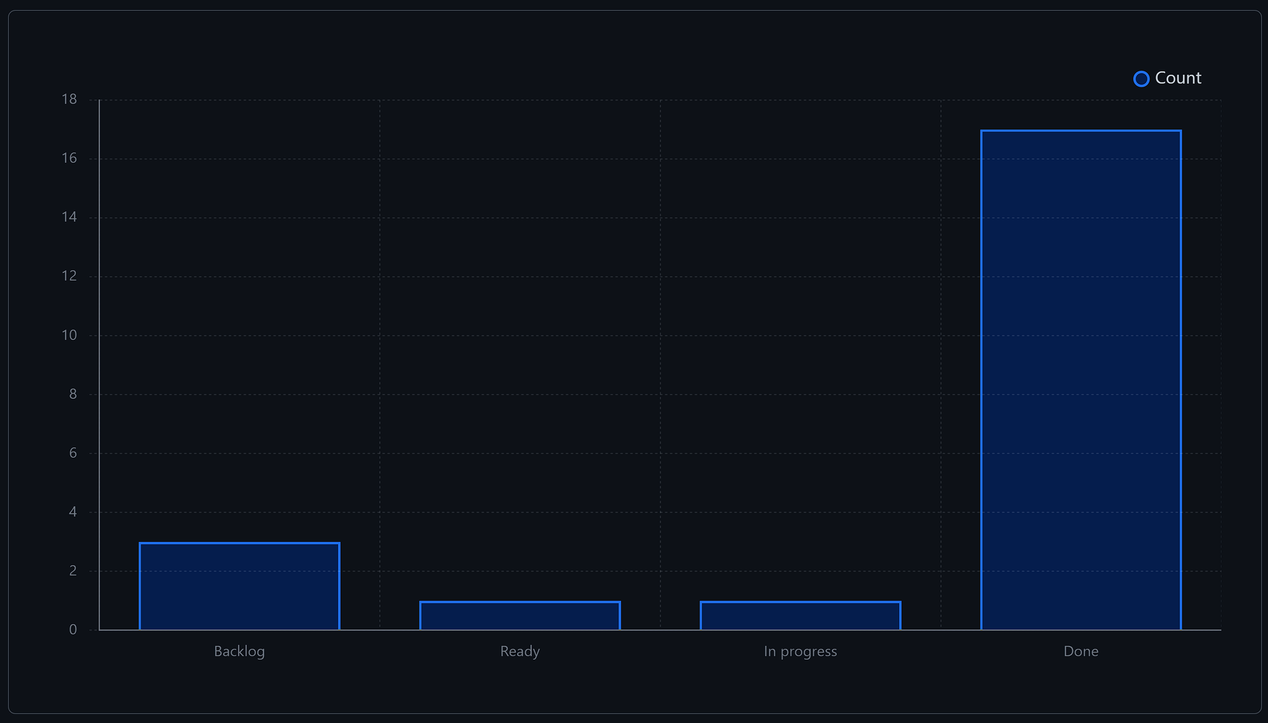
Figure 1: Weekly Activities
- In this week, there were a lot of issues resolved from the backlog, contributing to development.

Include charts/graphs (e.g., burn down charts) from your project management tool (Github/Zenhub) that shows your progress for the period of this report.
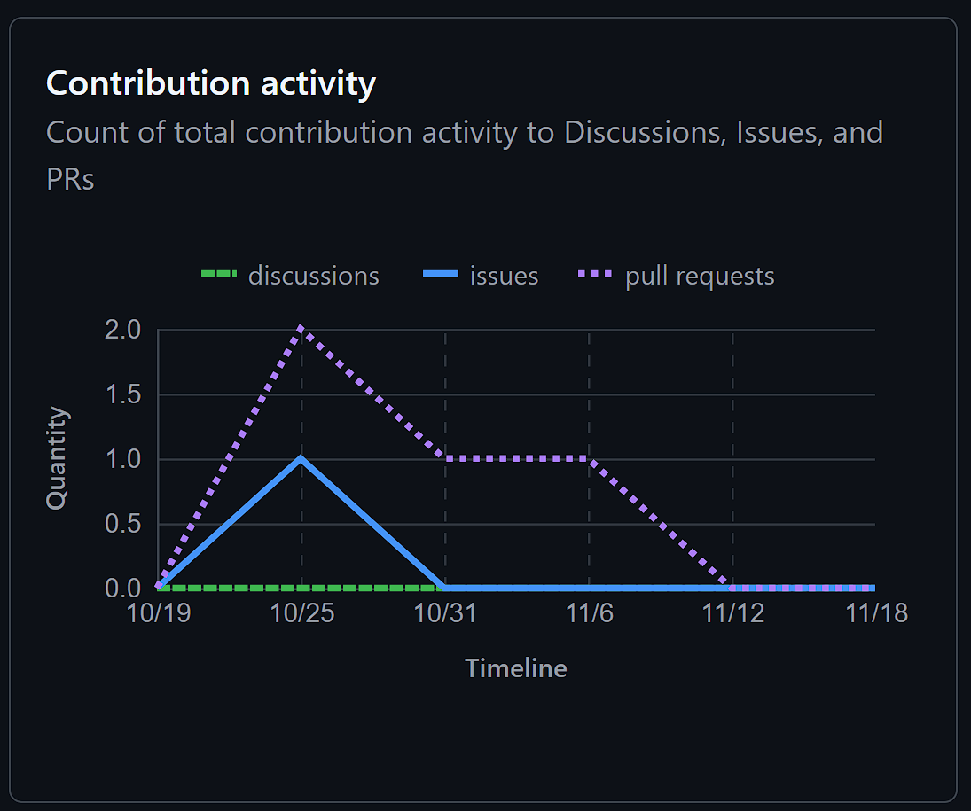
Figure 2: Contributors in the Week
- This week, we had a few PRs and issues resolved as compared to previous week, demonstrating team hard work and dedication.

Include a note and address to your project GitHub with list of codes uploaded/updated on GitHub in this reporting week.
GitHub: https://www.github.com/rachit-bhatt/Capstone-Project

